|  |  |
| --- | --- |
| **Course Title** | Phase 1 Integration Project |
| **Project Code** | PP1E v1-1 Project 2006-0104 |
| **Project Title** | Automatic Teller Simulator |
| **Institution** | CDI College |
| **Project done by** | Barsha Shaikh |
| **Student ID** | 635-201244 |
| **Date Completed** | 4/20/2021 |

*Modelling the ATM Requirements:*

Entity Forms:

|  |  |  |  |  |
| --- | --- | --- | --- | --- |
|  |  |  |  |  |
|  | Entity |  | Customers |  |
|  |  |  |  |  |
|  | Attributes |  | Name |  |
|  |  |  | PIN |  |
|  |  |  |  |  |
|  |  |  |  |  |
|  |  |  |  |  |

|  |  |  |  |  |
| --- | --- | --- | --- | --- |
|  |  |  |  |  |
|  | Entity |  | Transactions |  |
|  |  |  |  |  |
|  | Attributes |  | Deposit |  |
|  |  |  | Withdrawal |  |
|  |  |  | Transfer |  |
|  |  |  | Bill Payment |  |
|  |  |  | Account Type |  |
|  |  |  | PIN |  |
|  |  |  | Account Number |  |
|  |  |  | Account Balance |  |
|  |  |  |  |  |
|  |  |  |  |  |

|  |  |  |  |  |
| --- | --- | --- | --- | --- |
|  |  |  |  |  |
|  | Entity |  | Accounts |  |
|  |  |  |  |  |
|  | Attributes |  | Account type |  |
|  |  |  | PIN |  |
|  |  |  | Account number |  |
|  |  |  | Account Balance |  |
|  |  |  |  |  |

Data Element Forms:

|  |  |  |
| --- | --- | --- |
| Customers |  |  |
| Data Element | name |  |
| Alias | Customer name |  |
| Definition | Customer identifier |  |
| Type | C |  |
| Length | 20 |  |
| Picture | X(20) |  |
| Units |  |  |
| Range of Values |  |  |
|  |  |  |

|  |  |  |
| --- | --- | --- |
| Customers |  |  |
| Data Element | PIN |  |
| Alias | PIN Code |  |
| Definition | PIN number created for individual customer |  |
| Type | A |  |
| Length | 4 |  |
| Picture | X(4) |  |
| Units |  |  |
| Range of Values |  |  |
|  |  |  |

|  |  |  |
| --- | --- | --- |
| Transactions |  |  |
| Data Element | Deposit |  |
| Alias | Amount credited |  |
|  |  |  |
| Definition | Amount entered by the customer |  |
| Type | A |  |
| Length | 10 |  |
| Picture | X(10) |  |
| Units |  |  |
| Range of Values |  |  |
|  |  |  |

|  |  |  |
| --- | --- | --- |
| Transactions |  |  |
| Data Element | Withdrawal |  |
| Alias | Amount debited |  |
|  |  |  |
| Definition | Amount taken out by the customer |  |
| Type | C |  |
| Length | 4 |  |
| Picture | X(4) |  |
| Units |  |  |
| Range of Values | 10$-1000$ |  |
|  |  |  |

|  |  |  |
| --- | --- | --- |
| Transactions |  |  |
| Data Element | Transfer |  |
| Alias | Amount transfer |  |
|  |  |  |
| Definition | Amount transferred to another account |  |
| Type | D |  |
| Length | 4 |  |
| Picture | X(4) |  |
| Units |  |  |
| Range of Values | 10$-10000$ |  |
|  |  |  |

|  |  |  |
| --- | --- | --- |
| Transactions |  |  |
| Data Element | Bill payment |  |
| Alias | payment |  |
| Definition | Amount entered to pay utility or other bills |  |
| Type | C |  |
| Length | 4 |  |
| Picture | X(4) |  |
| Units |  |  |
| Range of Values | 10000 |  |
|  |  |  |

|  |  |  |
| --- | --- | --- |
| Accounts |  |  |
| Data Element | Account Type |  |
| Alias | Descriptive name of account type |  |
| Definition | Type of accounts saving or checking account |  |
| Type | A |  |
| Length | 1 |  |
| Picture | X(1) |  |
| Units |  |  |
| Range of Values |  |  |
|  |  |  |

|  |  |  |
| --- | --- | --- |
| Accounts |  |  |
| Data Element | PIN |  |
| Alias | Special instruction number |  |
|  |  |  |
| Definition | Preservative code like a password |  |
| Type | A |  |
| Length | 4 |  |
| Picture | X(4) |  |
| Units |  |  |
| Range of Values |  |  |
|  |  |  |

|  |  |  |
| --- | --- | --- |
| Accounts |  |  |
| Data Element | Account Number |  |
| Alias | Account identifier |  |
|  |  |  |
| Definition | Type of account where a number is assigned to enter |  |
| Type | C |  |
| Length | 5 |  |
| Picture | X(5) |  |
| Units |  |  |
| Range of Values |  |  |
|  |  |  |

|  |  |  |
| --- | --- | --- |
| Accounts |  |  |
| Data Element | Account balance |  |
| Alias | Amount |  |
|  |  |  |
| Definition | Amount in the respective account of the customer |  |
| Type | A |  |
| Length | 10 |  |
| Picture | X(10) |  |
| Units |  |  |
| Range of Values | 10-9000 |  |
|  |  |  |

Relationship Diagram:

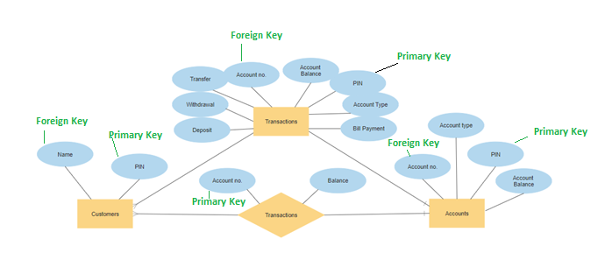

Data Flow Diagram:

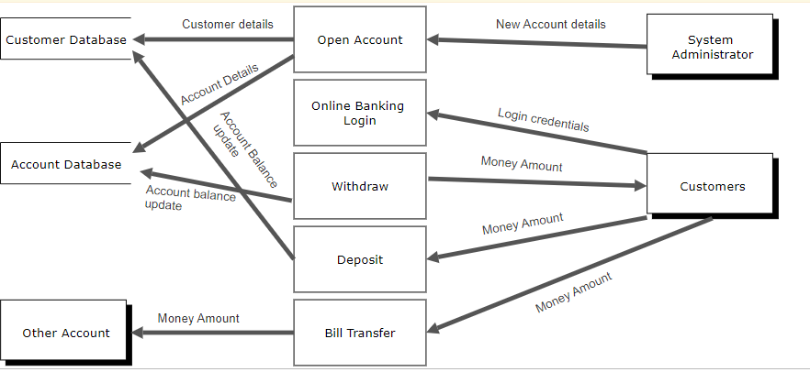

Flowchart:

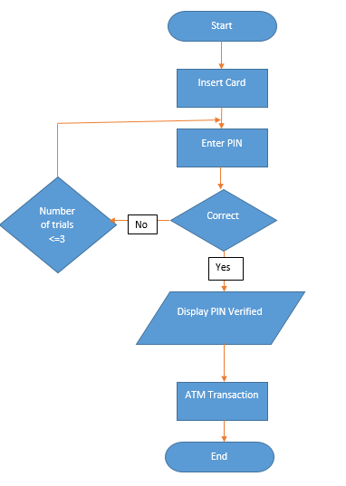

The PIN procedure handles the verification of the customer's Personal Identification Number (PIN) using data retrieved from the card's magnetic strip. The procedure invites the customer to enter their PIN using the keypad. If this does not match the PIN, a limited number of retries is permitted (less or equal to 3). If the correct PIN is entered, the ATM Transaction is called.

Pseudocode:

BEGIN

Insert Card

Enter PIN

IF PIN not correct

THEN Enter PIN  
 no. of trials >=3

IF PIN correct

DISPLAY PIN Verified

ENDIF

CALL ATM Transaction

END

Stop

Program Logic to write Source Code:

using namespace ATM;

int Main()

{

int PIN;

int password = 1234;

int count = 0;

int entry;

double deposit = 0.0;

double balance = 0.0;

double withdraw = 0.0;

bool isTrue = true;

do

{

cout << “***Welcome to TD Bank***\n”;

cout << “Enter your PIN:\n”;

cin >> PIN;

if(PIN == password)

{

cout << “***Welcome to TD Bank***\n”;

<< “1.Deposit\n”

<< “2.Withdraw\n”

<< “3.Transfer\n”

<< “4.Bill payment\n”

<< “5.Exit\n”;

cout << “Choose an option:\n”;

cin >> entry;

switch(entry)

{

case 1:

cout << “Deposit amount:\n”;

cin >> deposit;

balance = balance + deposit;

break;

case 2:

cout << “Withdraw amount:\n”;

cin >> withdraw;

balance = balance - withdraw;

break;

case 3:

cout << “Transfer balance$ << balance <<end1;

break;

case 4:

cout << “Bill payment:\n”;

cin >> Bill payment;

balance = balance + Bill payment;

break;

case 5:

cout << “Have a nice day!\n”;

isTrue = false;

break;

}

else

{

count++;

if(count ==3)

isTrue = false;

The PIN procedure

Tested by entering 2 digit the system prompted wrong PIN

The PIN was set to 4 digit

The function of Deposit of 500$ has been successfully executed

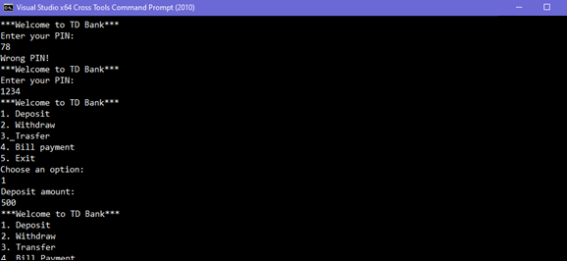

The function of Withdraw of 200$ has been successfully executed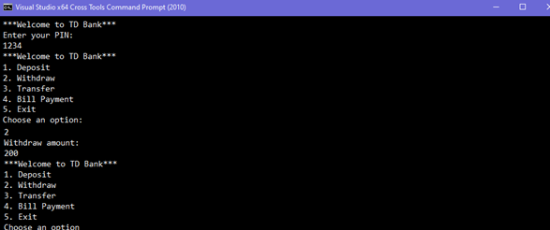Exit function was done successfully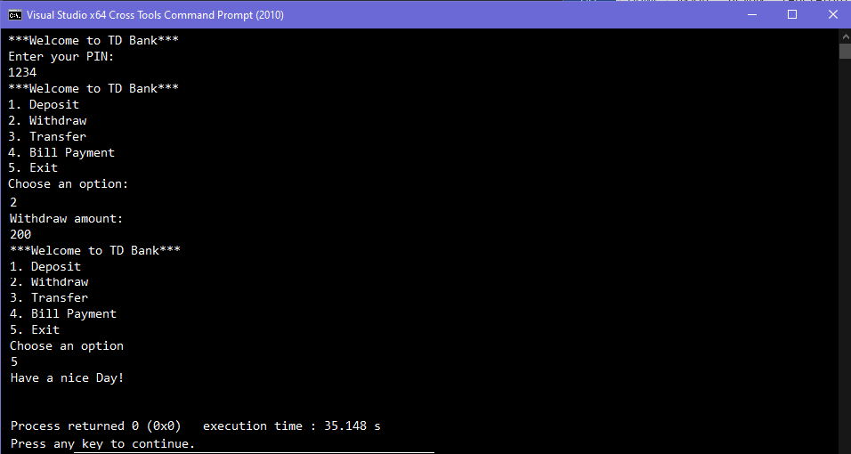

Class Design:

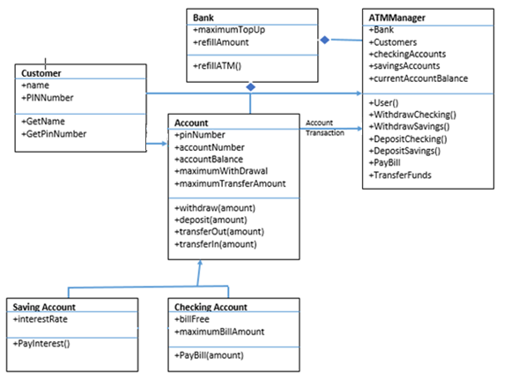

Main Form:

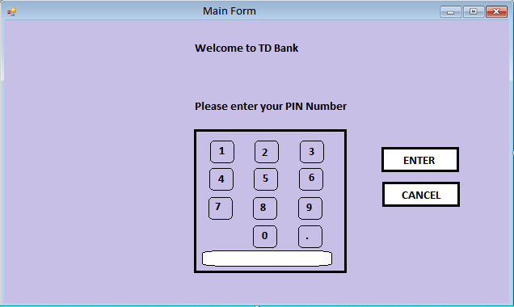

Login Form:

